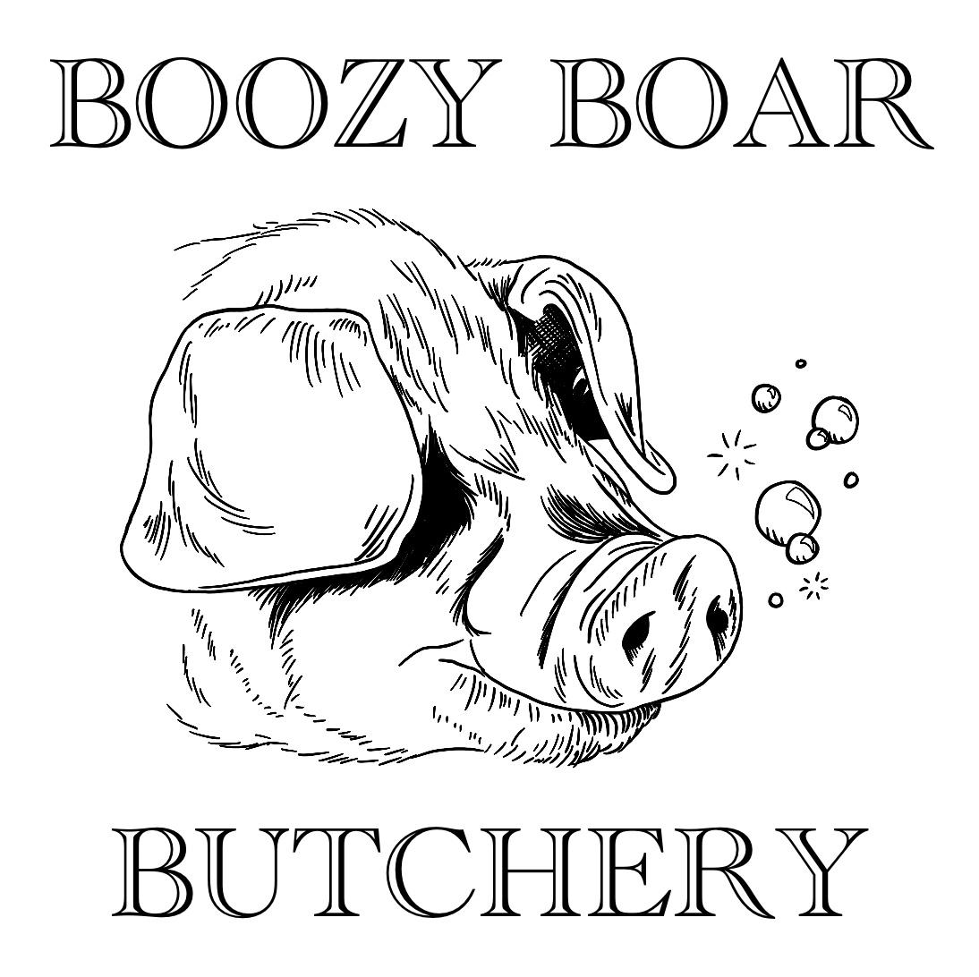
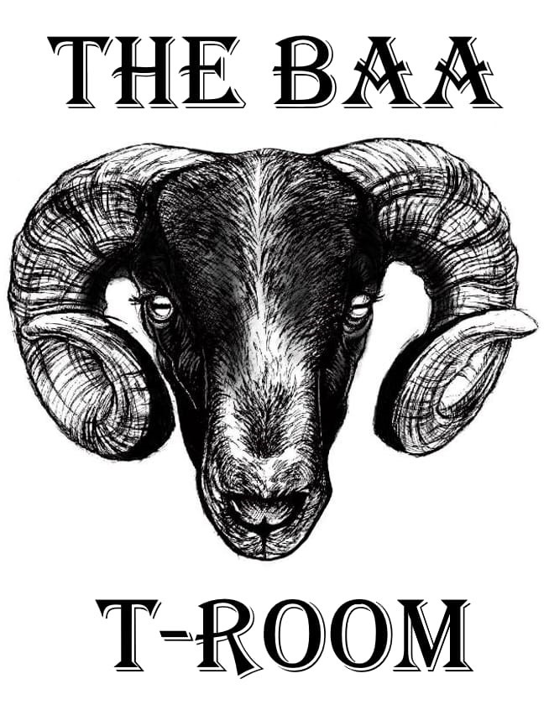
Breakfast menu
Available Mon - Fri 11am-1pm
Sat - Sun 10am-1pm

Please let your server know of any allergies or see the government guidelines food allergy notice by the bar

The Baa T-ROOM Full English
2 Slices of Boozy Boar Bacon,1 Boozy Boar Sausage,1 Free Range Fried Hen Egg, Mushrooms, Tomatoes, Hashbrown, Black Pudding, a Round of Toast and a Tea/Coffee
£9.95
Add a Pint £3.50
Change to a Fresh Duck Egg £0.50

Fried Eggs on Toast
2x Free Range Hen Eggs on 2x Slices of Toast
Brown/White
£4.95
Upgrade to Fresh Duck Eggs
£1.00

Scrambled Eggs on Toast
2x Free Range Hen Eggs on 2x Slices of Toast
Brown/White
£4.95
Upgrade to Fresh Duck Eggs
£1.00

Beans on toast
Baked Beans on 2x Slices of Toast
Brown/White
£3.95

Breakfast Bap
1 Boozy Boar Sausage, 1 Boozy Boar Bacon, Hashbrown and Free Range Egg on a Toasted Bap
£4.95

Sausage or Bacon Bap
1 Boozy Boar Cumberland Sausage or 2 Slices of Boozy Boar Bacon on a Toasted Bap
£3.95

Sausage and Bacon Bap
1 Boozy Boar Cumberland Sausage and 1 Boozy Boar Bacon on a Toasted Bap
£4.25

Quorn Sausage Bap
2x Quorn Sausages on a Toasted Bap
£3.95

Sides
Extra Egg 80p
Beans 90p
Mushrooms 90p
Hashbrown 90p
Black pudding 90p
Bacon Slice £1.00
Sausage £1.75

